MACHINE LEARNING
When should I use which method?
A visual student handbook: Classification • Regression • Forecasting • Clustering
CLASSIFICATION  Which category? | REGRESSION  What number?
FORECASTING  What happens next over time? | CLUSTERING  What groups exist?

Start with the question, not the algorithm
Before choosing a model, ask: What does the business want to know? What should the output look like? A category, a number, a future value over time, or natural groups?

1. The quickest way to choose
Four questions
1. Am I predicting a category? → Classification
2. Am I predicting a numeric value? → Regression
3. Am I predicting future values where time/order matters? → Forecasting
4. Do I have no target and want to discover similar groups? → Clustering

Business asks... | Output | Use | Simple example
Will this customer leave? | Class / label | Classification | Churn: Yes / No
What will this house cost? | Number | Regression | €385,000
How many units next month? | Future value over time | Forecasting | 1,250 units
Which customers behave similarly? | Groups | Clustering | 3 customer segments
CHECK YOUR UNDERSTANDING • A bank wants to predict whether a loan applicant will default: Yes or No. Which type?
Answer

2. Classification
When to use it
Which category or class does this case belong to?
Output: A label such as Yes/No, Fraud/Not Fraud, High/Medium/Low

Simple business example
Customer churn: use contract type, usage, complaints and payment history to predict whether a customer is likely to leave.
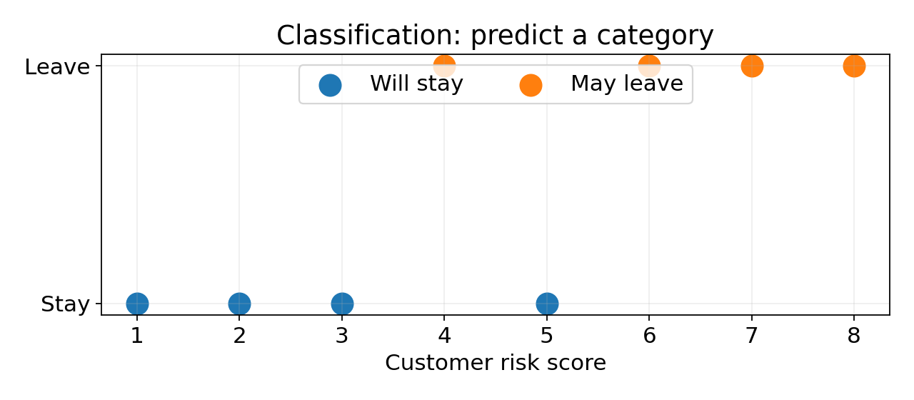

Think about the visual
The model separates observations into known classes. The important clue is that the answer is a label, not an exact numeric amount.
CHECK YOUR UNDERSTANDING • Predict whether an email is spam or not spam.
Answer

CHECK YOUR UNDERSTANDING • Predict the exact monthly bill amount.
Answer

3. Regression
When to use it
What numeric value should we predict?
Output: A continuous number such as price, revenue, duration or amount

Simple business example
Property price: use size, location-related variables, bedrooms and property characteristics to estimate a sale price.
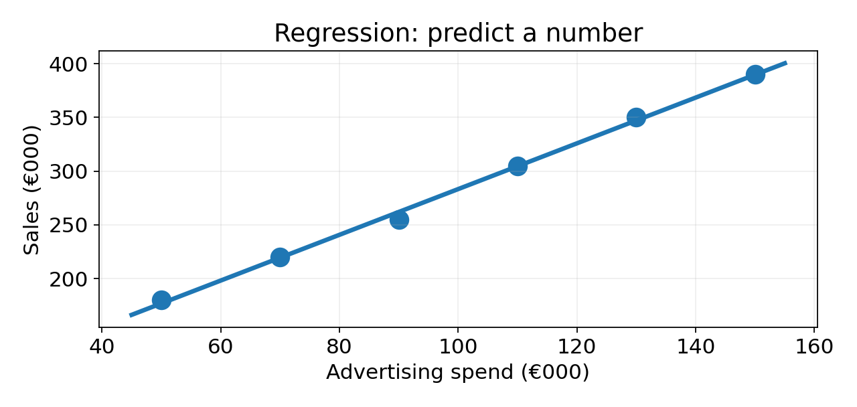

Think about the visual
The points show observed values and the line represents a numeric relationship used to estimate a continuous outcome.
CHECK YOUR UNDERSTANDING • Predict delivery time in minutes.
Answer

CHECK YOUR UNDERSTANDING • Predict whether delivery will be late: Yes or No.
Answer

4. Forecasting
When to use it
What is likely to happen in the future, using time-ordered historical data?
Output: A future value or sequence such as next week sales or next month demand

Simple business example
Retail demand: use weekly sales history, seasonality and other relevant factors to estimate demand for future weeks.
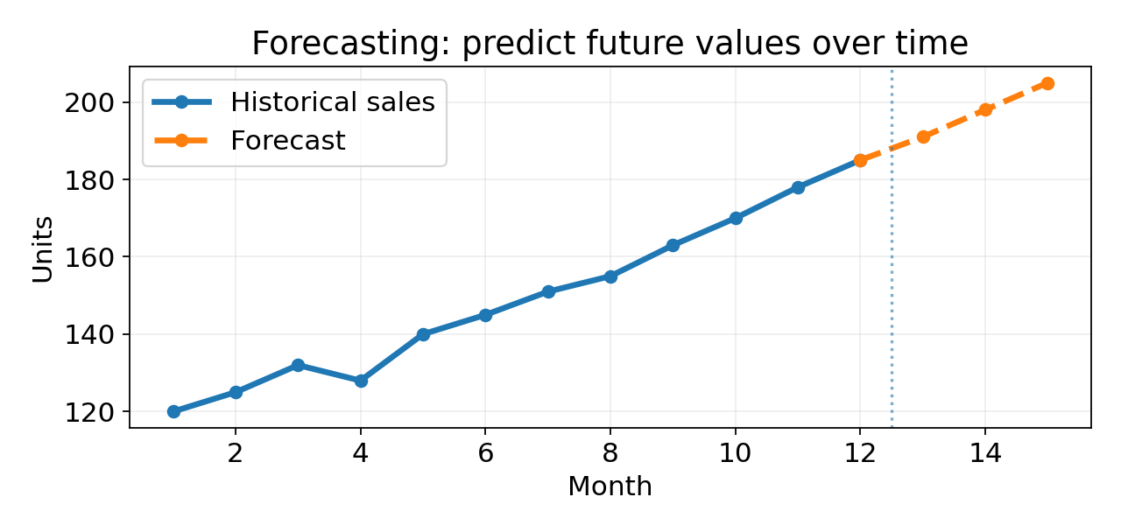

Think about the visual
The order of observations matters. Historical values come first; the task is to estimate values beyond the observed time period.
CHECK YOUR UNDERSTANDING • Predict electricity demand for each day next week.
Answer

CHECK YOUR UNDERSTANDING • Estimate a property price from its features.
Answer

5. Clustering
When to use it
Are there natural groups in the data when no target label is given?
Output: Groups/segments formed from similarity

Simple business example
Customer segmentation: group customers using purchase frequency and average spend to discover different behavioural segments.
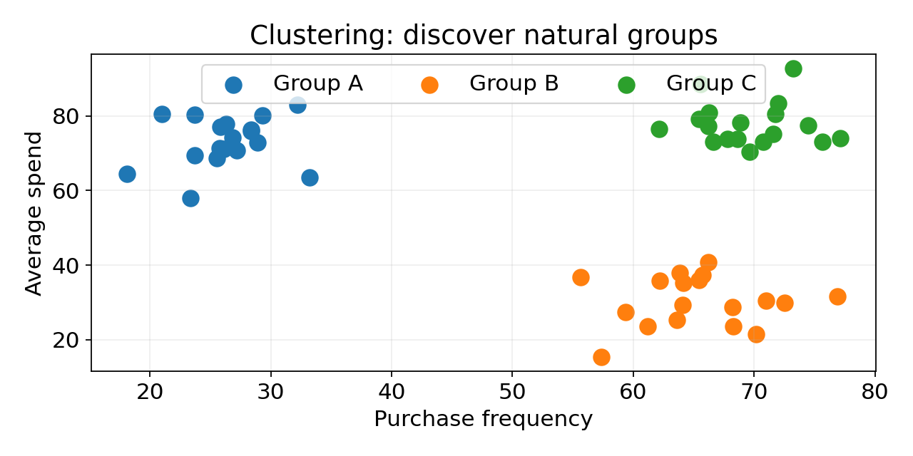

Think about the visual
There is no predefined target such as “Segment A”. The aim is to discover groups of observations that are similar to one another.
CHECK YOUR UNDERSTANDING • Group shoppers into similar purchasing patterns without predefined labels.
Answer

CHECK YOUR UNDERSTANDING • Predict whether a known customer belongs to Premium or Standard when historical labels already exist.
Answer

6. Same business, different ML question
The industry does not determine the ML method. The question and required output do.
Context | Business question | Method
Hotel | Will this booking be cancelled? | Classification
Hotel | What will the booking value be? | Regression
Hotel | How many rooms will be booked next month? | Forecasting
Hotel | What types of guests naturally appear in our data? | Clustering
Retail | Will a customer respond to a campaign? | Classification
Retail | How much will a customer spend? | Regression
Retail | What will weekly demand be next quarter? | Forecasting
Retail | Which customers have similar buying behaviour? | Clustering
CHECK YOUR UNDERSTANDING • A supermarket wants to know both (a) whether a customer will churn and (b) how much the customer is likely to spend next month. Is this one ML task?
Answer
No. (a) is classification because the output is a class. (b) is regression if the goal is a numeric spend estimate. If the task is forecasting total store sales over future time periods, forecasting becomes the focus.

7. Quick online activity: Which method?
For each question, choose: Classification, Regression, Forecasting or Clustering. Decide from the required output.
1. A telecom company wants to identify customers likely to cancel their contract.
Your answer: ______________________________

2. A delivery company wants to estimate delivery duration in minutes.
Your answer: ______________________________

3. A restaurant wants to estimate daily demand for the next 14 days.
Your answer: ______________________________

4. A retailer wants to discover groups of customers with similar buying behaviour.
Your answer: ______________________________

5. A bank wants to identify potentially fraudulent transactions.
Your answer: ______________________________

6. A hotel wants to estimate the monetary value of a booking.
Your answer: ______________________________

7. An energy company wants to predict hourly electricity demand for tomorrow.
Your answer: ______________________________

8. A streaming service wants to discover different viewing-behaviour segments without predefined labels.
Your answer: ______________________________

Check your answers
1. Classification
2. Regression
3. Forecasting
4. Clustering
5. Classification
6. Regression
7. Forecasting
8. Clustering

8. Common mistakes to avoid
Avoid: “The data contains numbers, so use regression.”
Incorrect. Classification can also use numeric input features. Look at the target/output.

Avoid: “Anything about the future is forecasting.”
Not always. Forecasting is especially appropriate when time order/history is central to the prediction.

Avoid: “Clustering predicts known customer types.”
If the types are already labelled and you want to predict them, that is classification. Clustering discovers groups without predefined target labels.

Avoid: “Choose Random Forest first, then find a problem.”
Reverse the order: business question → target/output → ML task → suitable algorithm.

10. One-page decision guide
CLASSIFICATION
Use when the target is a category.
Clue words: classify, identify, yes/no, type, class, risk group.
Example: Will a customer churn?

REGRESSION
Use when the target is a numeric value.
Clue words: amount, price, duration, value, score.
Example: What will the property price be?

FORECASTING
Use when predicting future values from time-ordered history.
Clue words: next week, next month, future demand, trend, seasonality.
Example: What will sales be next month?

CLUSTERING
Use when there is no predefined target and you want to discover similar groups.
Clue words: segment, group, similar behaviour, patterns.
Example: What customer segments exist?

BUSINESS PROBLEM → QUESTION → OUTPUT → ML TASK → ALGORITHM

